***Methods and Calculation***

The process of estimation can be divided into three basic steps: preprocessing data, separating track points and identifying the maximum queue length.

**Step1: Data preprocessing**

In order to manage data from different perspectives, trajectories data in one row should be divided into different rows according to timestamp. The treated data are in this form:

**Table 1** the Form of Data (After Preprocessing)

|  |  |  |  |  |  |  |  |  |  |
| --- | --- | --- | --- | --- | --- | --- | --- | --- | --- |
| track_id | type | traveled_d | avg_speed | lat | lon | speed | lon_acc | lat_acc | time |
| 56 | car | 217.13 | 47.08918 | 37.99197 | 23.73131 | 50.7359 | -0.0181 | -0.0425 | 0 |
| 56 | car | 217.13 | 47.08918 | 37.99196 | 23.73131 | 50.7349 | 0.0043 | -0.049 | 0.04 |
| … | … | … | … | … | … | … | … | … | … |

**Step2: Separating track points**

According to the map, the areas of interest are the following three: 1. Leof. Alexandras, with direction towards 28is Oktovriou (approximately, the red area in the attached file); 2. 28is Oktovriou, with direction towards Leof. Alexandras (approximately, the yellow area in the attached file); 3. 28is Oktovriou, above Leof. Alexandras with direction towards the South (approximately, the green area in the attached file)

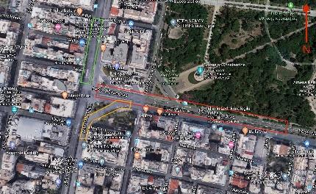 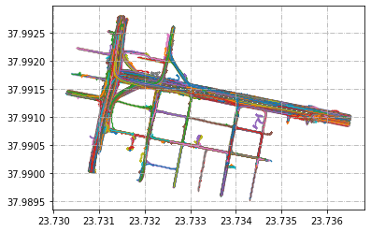

**Figure 1** Areas of Interest  **Figure 2** Scatter Plot of Track Points

The scatter plot of track points were drawn from processed data. In order to better understand the spatial distribution of trajectories in the specific areas, the corresponding track points should be separated.

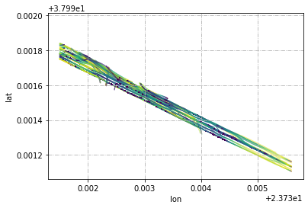 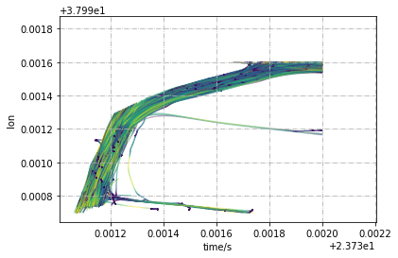

**Figure 3** Scatter Plot of Track Points (Area 1)  **Figure 4** Scatter Plot of Track Points (Area 2)

**Step3: Identifying the maximum queue length**

After separating the trajectories, the problem is that the scatter plot could not illustrate queue status variation temporally, which can be settled by demonstrating the temporal-spatial diagram. From the temporal-spatial plot the maximum queue length can be positioned.

**① Area 1**

The scatter plot of target points (longitude versus time) were shown in Figure 5. It is shown that there existed spillback between upstream and downstream nodes in this area. Figure 6 shows track points which speed equal to zero, and it is obvious that the maximum queue length occurred when the queue extended to upstream node in one signal cycle.

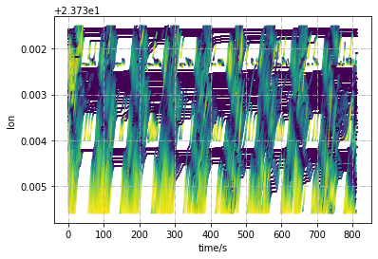 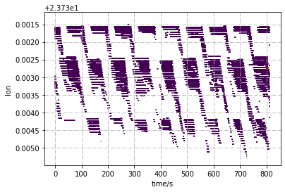

**Figure 5** Temporal-spatial Plot (Area 1)  **Figure 6** Temporal-spatial Plot (Speed = 0; Area 1)

In order to observe queueing status for each lane, the temporal-spatial track points on different lanes were separated.

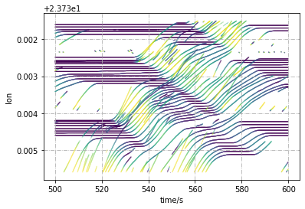

**Figure 7** Temporal-spatial Plot (Middle Lane; timestamp = 500 ~ 600s; Area 1)

The maximum queue length occurred at the middle lane when timestamp = 576.56s (see Figure 7), at which a car (id = 1708) stopped at the end of the queue (longitude = 23.7351, latitude = 37.9912). After transferring WGS-84 coordinates to real position, the queue length is computed as 348.8317m.

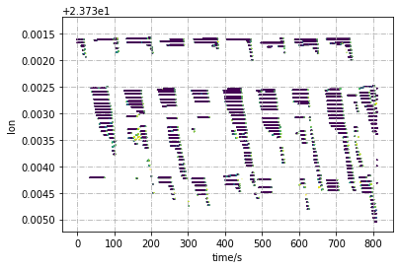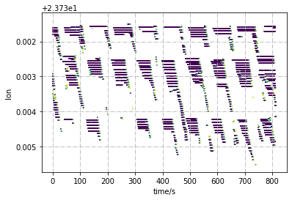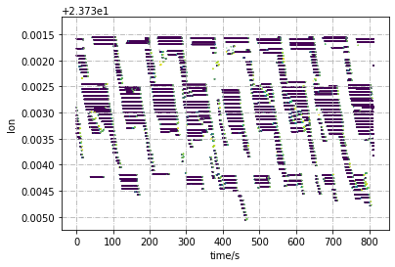

(1) Left Lane (2) Middle Lane (3) Right Lane

**Figure 8** Temporal-spatial Plot (Speed = 0; Area 1)

Figure 8 shows that spillback occurred at each lane during almost each traffic signal cycle.

**② Area 2**

According to the method above, the maximum queue length in Area 2 was observed at the timestamp of 650~750s, and the corresponding temporal-spatial track points were illustrated in Figure 9.

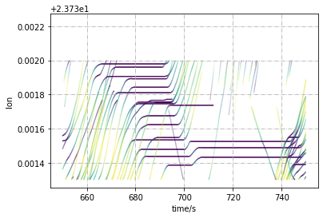

**Figure 9** Temporal-spatial Plot (timestamp = 650 ~ 750s; Area 2)

The maximum queue length occurred when timestamp = 696.44s (see Figure 9), at which a car (id = 1971) stopped at the end of the queue (longitude = 23.7314, latitude = 37.9914). After transferring WGS-84 coordinates to real position, the queue length is computed as 69.8321m.

The queuing status was observed at the ramp region, so there was not spillback condition at Area 2.

**③ Area 3**

Figure 10 shows that how signal control affects traffic movement at intersection. Queue was spilled back to upstream intersection during each signal cycle.

The maximum queue length in Area 3 was observed at the timestamp of 300~375s, and the corresponding temporal-spatial track points were illustrated in Figure 11.

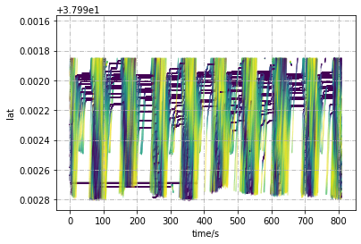 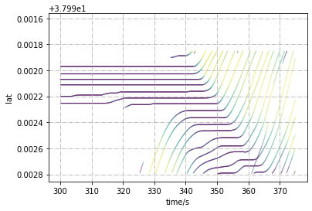

**Figure 10** Temporal-spatial Plot (Area 3) **Figure 11** Temporal-spatial Plot (timestamp = 300 ~ 375s; Area 3)

The maximum queue length occurred when timestamp = 353.4s (see Figure 9), at which a car (id = 1166) stopped at the end of the queue (longitude = 23.7315, latitude = 37.9928). After transferring WGS-84 coordinates to real position, the queue length is computed as 82.2817m.